**REACT WEEK 7 HANDSON**

Create a React Application “eventexamplesapp” to handle various events of the form elements in HTML.

1. Create “Increment” button to increase the value of the counter and “Decrement” button to decrease the value of the counter. The “Increase” button should invoke multiple methods.
   1. To increment the value
   2. Say Hello followed by a static message.

**SOLUTION:**

**App.js**

import React, { useState } from 'react';

import './App.css';

function App() {

  const [count, setCount] = useState(5);

  const [amount, setAmount] = useState('');

  const [currency, setCurrency] = useState('');

  const handleIncrement = () => {

    setCount(count + 1);

    alert("Hello Member1!");

  };

  const handleDecrement = () => {

    setCount(count - 1);

  };

  const sayWelcome = () => {

    alert("Welcome to Currency Converter");

  };

  const handleClick = () => {

    console.log("Button was clicked!");

  };

  const handleSubmit = (e) => {

    e.preventDefault();

    alert(`Amount: ${amount} | Currency: ${currency}`);

  };

  return (

    <div className="App">

      <h3>{count}</h3>

      <button onClick={handleIncrement}>Increment</button><br />

      <button onClick={handleDecrement}>Decrement</button><br />

      <button onClick={sayWelcome}>Say welcome</button><br />

      <button onClick={handleClick}>Click on me</button>

      <h2 className="heading">Currency Convertor!!!</h2>

      <form onSubmit={handleSubmit}>

        <label>Amount:</label>

        <input

          type="text"

          value={amount}

          onChange={(e) => setAmount(e.target.value)}

        /><br />

        <label>Currency:</label>

        <textarea

          value={currency}

          onChange={(e) => setCurrency(e.target.value)}

        /><br />

        <button type="submit">Submit</button>

      </form>

    </div>

  );

}

export default App;

**OUTPUT:**

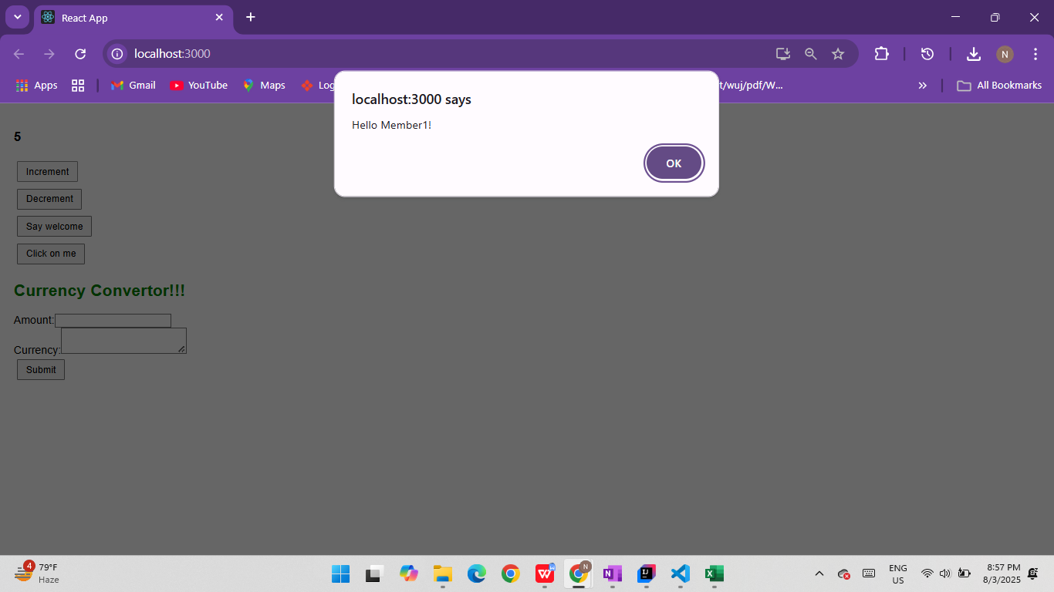

**App.js:**

import React, { useState } from "react";

function App() {

  const [count, setCount] = useState(0);

  const [amount, setAmount] = useState("");

  const [currency, setCurrency] = useState("");

  const handleIncrement = () => {

    incrementCounter();

    sayHello();

  };

  const incrementCounter = () => {

    setCount(count + 1);

  };

  const sayHello = () => {

    alert("Hello Member!");

  };

  const handleDecrement = () => {

    setCount(count - 1);

  };

  const sayWelcome = (message) => {

    alert(message);

  };

  const handleClick = () => {

    alert("You clicked the button!");

  };

  const handleSubmit = (e) => {

    e.preventDefault();

    console.log("Amount:", amount);

    console.log("Currency:", currency);

  };

  return (

    <div style={{ padding: "20px" }}>

      <h3>{count}</h3>

      <button onClick={handleIncrement}>Increment</button><br />

      <button onClick={handleDecrement}>Decrement</button><br />

      <button onClick={() => sayWelcome("Welcome")}>Say Welcome</button><br />

      <button onClick={handleClick}>Click on me</button>

      <h2 style={{ color: "green" }}>Currency Convertor!!!</h2>

      <form onSubmit={handleSubmit}>

        <label>

          Amount:

          <input

            type="text"

            value={amount}

            onChange={(e) => setAmount(e.target.value)}

          />

        </label>

        <br />

        <label>

          Currency:

          <input

            type="text"

            value={currency}

            onChange={(e) => setCurrency(e.target.value)}

          />

        </label>

        <br />

        <button type="submit">Submit</button>

      </form>

    </div>

  );

}

export default App;

**OUTPUT:**

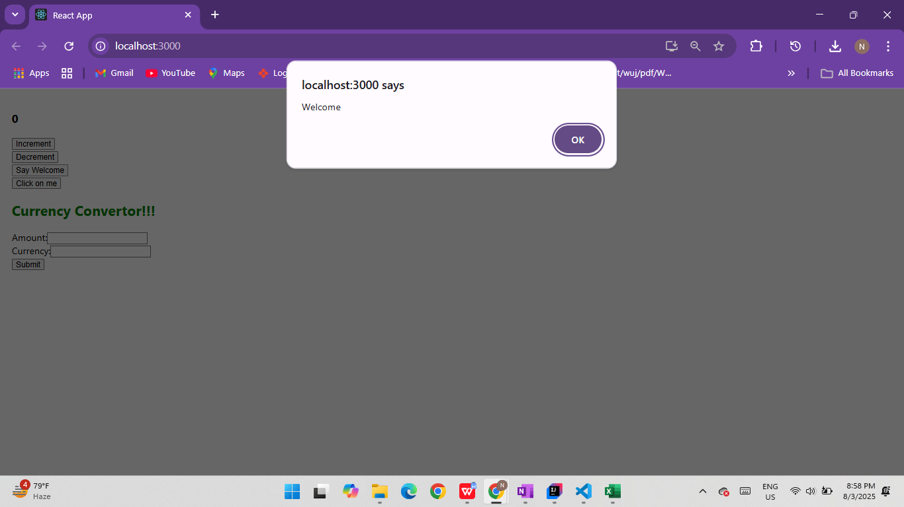

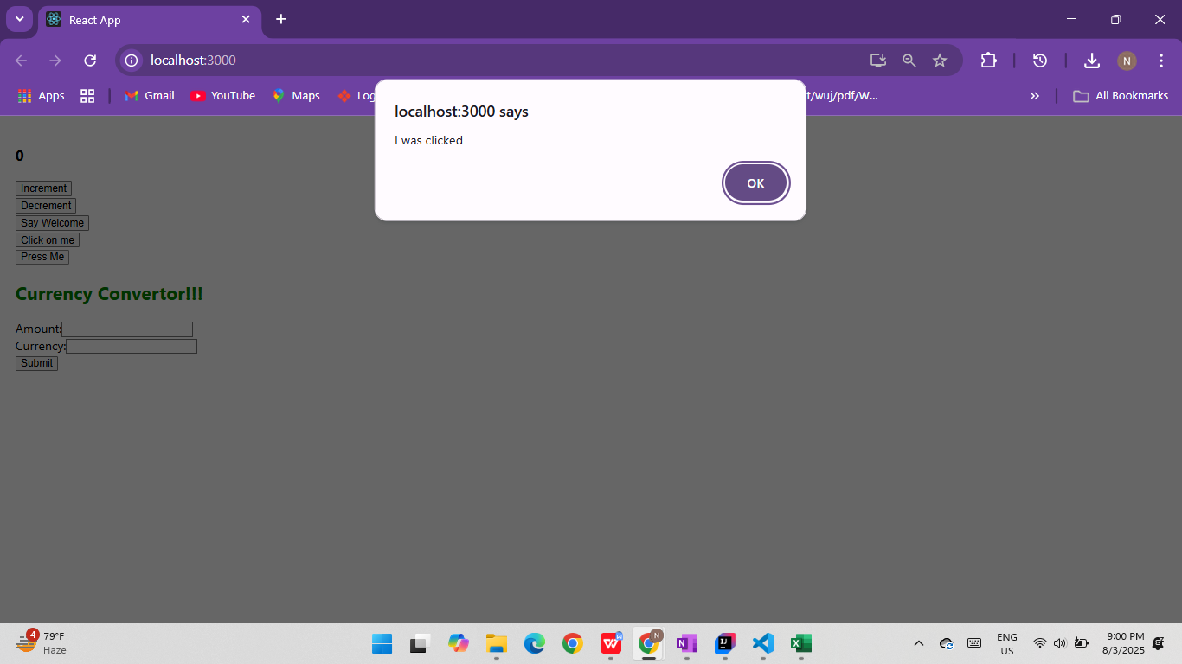

App.js

import React, { useState } from "react";

import CurrencyConvertor from "./components/CurrencyConvertor";

function App() {

  const [count, setCount] = useState(0);

  const increment = () => {

    setCount(count + 1);

    sayHello();

  };

  const decrement = () => {

    setCount(count - 1);

  };

  const sayHello = () => {

    console.log("Hello! This is a static message.");

  };

  const sayWelcome = (msg) => {

    alert(`Welcome message: ${msg}`);

  };

  const handlePress = () => {

    alert("I was clicked");

  };

  return (

    <div style={{ padding: "20px" }}>

      <h1>Event Examples App</h1>

      <h2>Counter: {count}</h2>

      <button onClick={increment}>Increment</button>{" "}

      <button onClick={decrement}>Decrement</button>

      <br /><br />

      <button onClick={() => sayWelcome("Welcome to React!")}>

        Say Welcome

      </button>

      <br /><br />

      <button onClick={handlePress}>OnPress</button>

      <br /><br />

      <CurrencyConvertor />

    </div>

  );

}

export default App;

**OUTPUT:**

